Vendor Invoice Work flow:
- Go to FV60
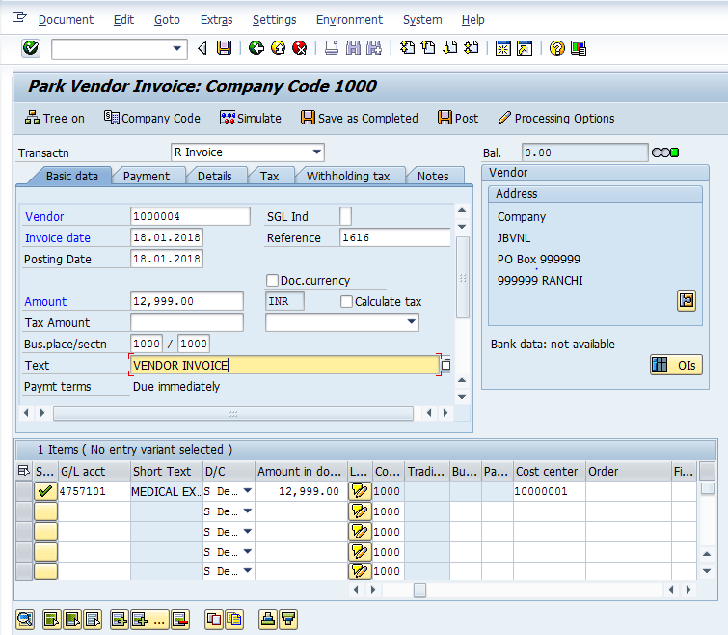
The following are the Input fields under the Document Header data of Vendor Invoice
- Vendor: Input the Vendor Number in the Vendor field with help of press “F4” button to search vendor number.
- Invoice Date: Input the Invoice date in the field
- Posting Date: Input the transaction date in the Posting date field
- Currency: Input the Currency INR in the Currency field
- Reference: Input the Reference field with Reference (invoice) number
- Text: Input the Text Information in text field Eg: Vendor invoice posting with Tax
- Calculate Tax: Check the Calculate Tax check box for calculating tax. Select respective tax from drop down list Eg: S3 14% ST+.5%SCB
- Section Code: Input the Withholding tax section code in this field in case of TDS is applicable.
Line Item:
- GL Account: Place the Cursor on the field and press F4. Select the respective GL Account and press Enter key
- Debit/Credit: Select Debit/Credit option from drop down list
- Text Field: Input the Text information e. g.: Vendor Invoice posting with Tax
- Cost Center: Place the cursor on the field and press F4. Select the respective Cost Center and press Enter key
- Profit Center: Profit Center will get automatically updated (through Cost Center Profit Center will get updated) as configured
Click on Park option in Tool bar
System will pop up the message at the bottom of the screen “Document 1000000011 was Parked.

Document 1000000011 1000 was Parked

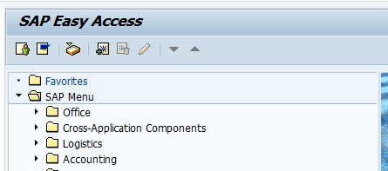
- Go to SAP Easy Access and Click on Business Workflow Option. Then the below screen will appear.

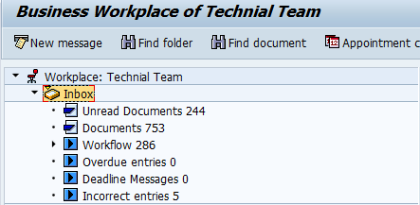

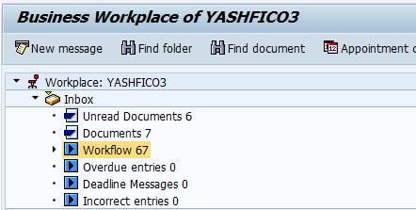

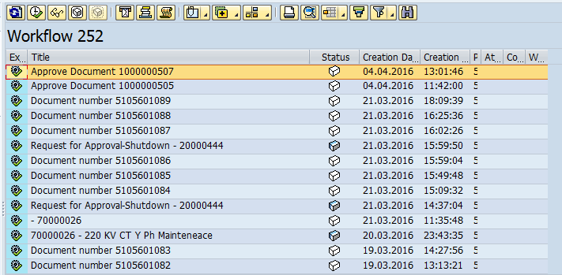

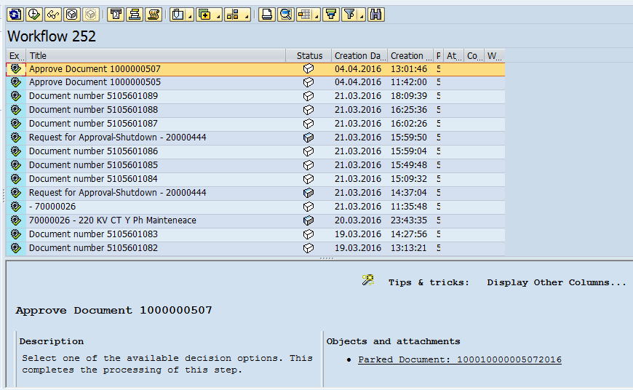

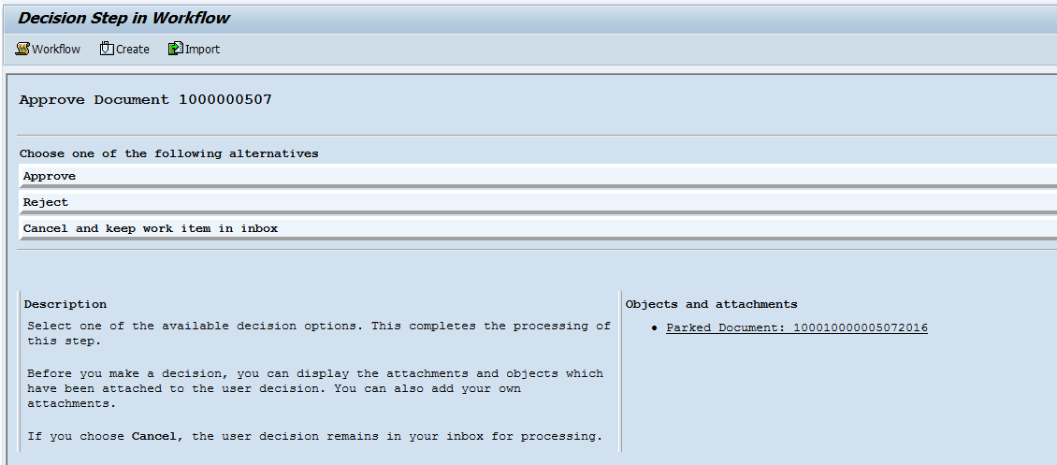

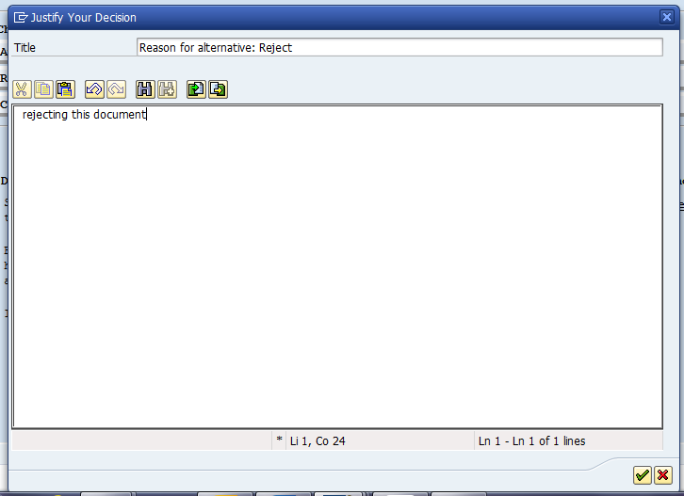

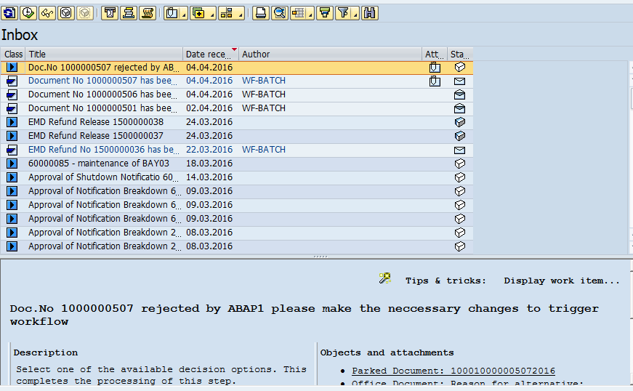

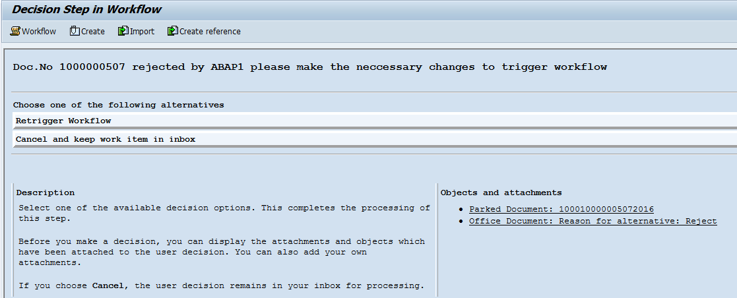

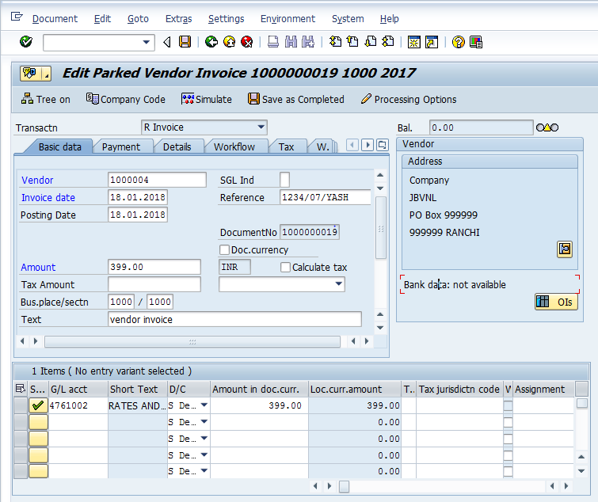

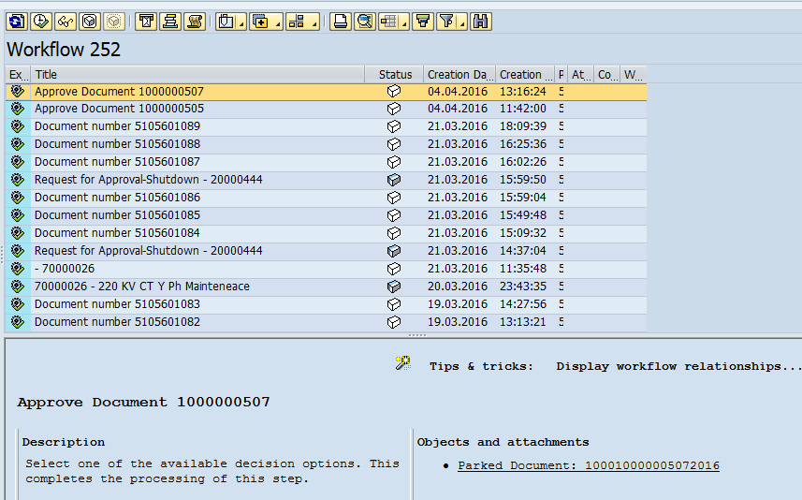

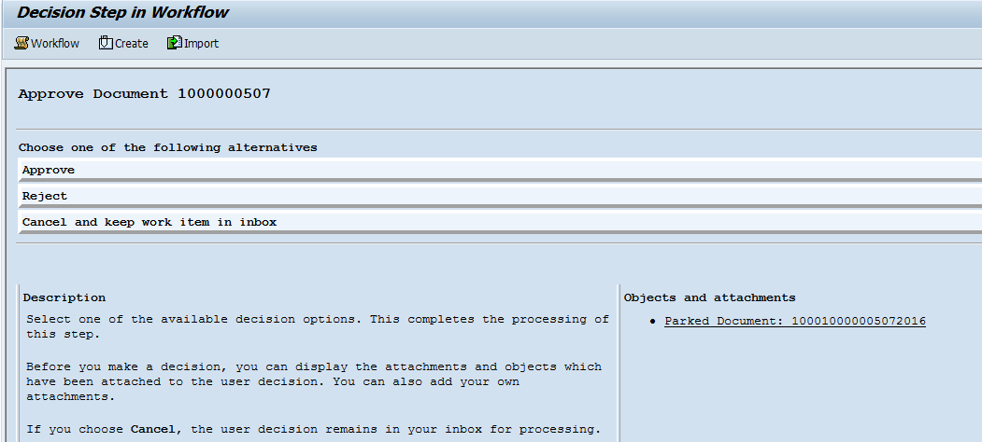

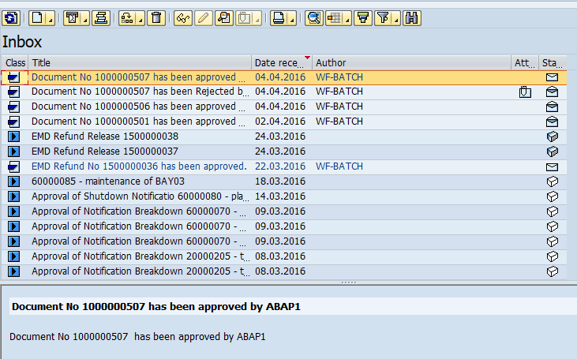

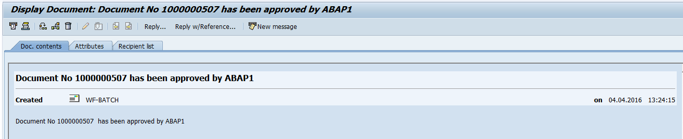

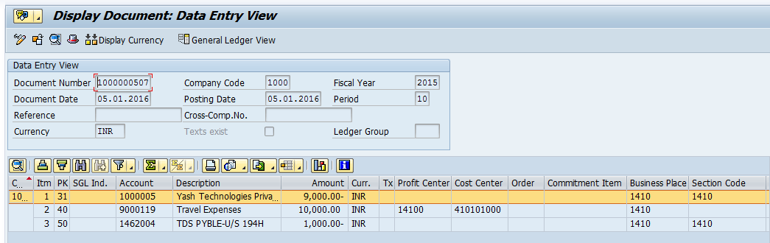

Note: In case of Rejection system will send notification to the creator and also to the user levels (approval persons) where the creator need to create a new invoice for approval.

